Name

Mathematics Extension 1 Year 12
Central Limit Theorem

Book 1 |  | Version: 261026  Feedback:  https://MrDingMaths.com
Contents
Syllabus Content 1
The Sample Proportion 2

Syllabus Content
ME1-12-06 solves problems involving binomial distributions, sampling distribution of the mean and the central limit theorem
Sampling distribution of the mean and the central limit theorem
- Define a statistical population as the entire group of people or objects about which information is sought
- Define a sample as a selection of people or objects drawn from a population
- Recognise that a statistic taken from a sample will be a good approximation if the sample is random and the sample size is large enough, typically $n≥30$
- Recognise that, in general, the distribution of a population and a statistic, such as its mean, are unknown
- Recognise that it is likely that the distribution of a random sample will resemble the distribution of the population when the sample size, $n$, is large enough, typically $n≥30$
- Define the sample mean for a sample $X_{1},X_{2},…,X_{n}$taken from a population as $\overline{X}=\frac{1}{n}\sum_{i=1}^{n}{X_{i}}$
- Recognise that the sample means obtained from repeated sampling may be different, even if all the samples are of the same size
- Define, for a given sample size $n$, the sampling distribution of the mean to be the distribution of the sample means of all samples of size $n$
- Recognise that sample mean, $\overline{X}$, is a random variable that estimates the population mean, $μ$, when the size of the sample is large enough and consider its usefulness in making predictions in a variety of contexts including politics, finance, agriculture and biology
- State the central limit theorem as: for a population with mean $μ$ and variance $σ^{2}$, provided the sample size $n$ is large enough ($n≥30$), the sampling distribution is approximately normal with mean $μ$and variance $\frac{σ^{2}}{n}$; that is, $\overline{X}$ is approximately$N\left(μ,\frac{σ^{2}}{n}\right)$
- Recognise the significance of the central limit theorem for populations that are not necessarily normally distributed; that, irrespective of the population distribution, for a sufficiently large sample size, the sampling distribution of the mean is approximately normal
- Use the formulas $E\left(\overline{X}\right)=μ$ and $\text{Var}\left(\overline{X}\right)=\frac{σ^{2}}{n}$ as the mean and the variance of the sampling distribution of the mean for samples of size $n$ drawn from a population with mean $μ$ and variance $σ^{2}$
- Examine the effect of the sample size on the variance of sample means with digital tools
- Apply the central limit theorem to estimate the probability that the sample mean lies within given bounds

The Sample Proportion

- Investigation The sample proportion
Imagine that a city has a population of 1 million people, with 40% owning a bicycle.
You repeatedly survey random samples of 1000 people and record the results.
Let $X$ be the number of bicycle owners in a sample. Since each person either owns a bicycle or doesn’t, $X$ is a ………………… random variable.
Calculate the proportion $\hat{p}$ of people in each sample who own a bike.

Sample A: 437 out of 1000 people own a bike. ${\hat{p}}_{A}=$ …………
Sample B: 412 out of 1000 people own a bike. ${\hat{p}}_{B}=$ …………
Sample C: 385 out of 1000 people own a bike. ${\hat{p}}_{C}=$ …………

The sample proportion $\hat{p}$ is the number of successes recorded in a sample ($X\sim Bin\left(n,p\right)$), divided by the sample size $n$.
$$\hat{p}=\frac{X}{n}$$

The distribution of $\hat{p}$ is just the distribution of $X$ horizontally dilated by factor $\frac{1}{n}$.
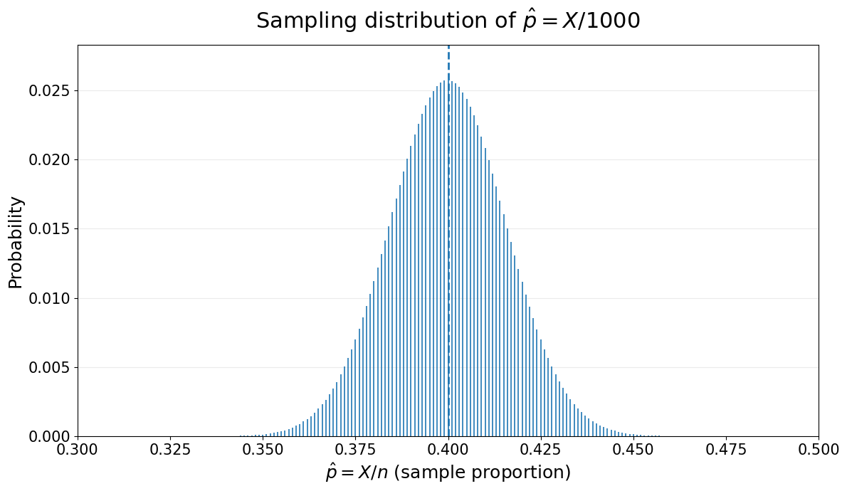
Notice that the probabilities are the same $P\left(\hat{p}=\frac{r}{n}\right)=P\left(X=r\right)=\left(\begin{aligned}n \\ r\end{aligned}\right)p^{r}q^{n-r}$ since we are relabelling each $x$ value: 400 $↦$ 0.4.
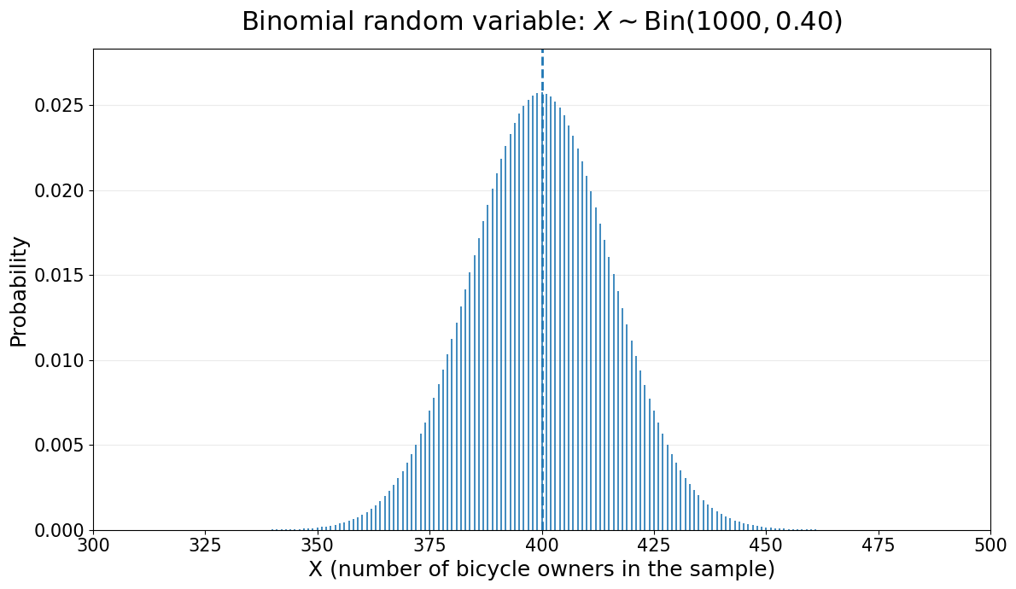

If we take lots of samples and average the results, we get a good estimate of the true probability (law of large numbers) and for sufficiently large numbers of trials, the distribution of sample proportions becomes approximately normal (central limit theorem).

Statisticians usually work with sample proportions because proportions can be compared across samples of different sizes and directly estimate a population percentage. Saying “40% of people own a bicycle” is generally more useful than saying “400 people own a bicycle”, because the second statement depends on the sample size.
- Sample Proportions
The sample proportion $\hat{p}$ is the number of successes recorded in a sample ($X\sim Bin\left(n,p\right)$), divided by the sample size $n$.
$$\hat{p}=\frac{X}{n}$$
Expected Value  $$E\left(\hat{p}\right)=E\left(\frac{X}{n}\right) \\ =\frac{E\left(X\right)}{n} \\ =\frac{np}{n} \\ =p$$ | Variance  $$Var\left(\hat{p}\right)=Var\left(\frac{X}{n}\right) \\ =\frac{E\left(X\right)}{n^{2}} \\ =\frac{np\left(1-p\right)}{n^{2}} \\ =\frac{p\left(1-p\right)}{n}$$ | Standard Deviation  $$σ\left(\hat{p}\right)=\sqrt{Var\left(X\right)} \\ =\sqrt{\frac{np\left(1-p\right)}{n^{2}}} \\ =\frac{\sqrt{np\left(1-p\right)}}{n}$$

- Example Calculate $E\left(\hat{p}\right), Var\left(\hat{p}\right)$ and $σ\left(\hat{p}\right)$
A factory produces circuit boards. In the long run, 30% of boards are faulty. A random sample of 150 boards is taken. Let $X$ be the number of faulty boards in the sample, and let $\hat{p}=\frac{X}{150}$
Find $E\left(\hat{p}\right)$ and $σ\left(\hat{p}\right)$
$$X∼\text{Bin}\left(150,0.3\right)$$  $$E\left(\hat{p}\right)=p=0.3$$ | $$Var\left(\hat{p}\right)=\frac{p\left(1-p\right)}{n}=\frac{0.3\left(1-0.3\right)}{150}=0.0014 \\ σ\left(\hat{p}\right)=\sqrt{Var\left(\hat{p}\right)}=\sqrt{0.0014}$$

- Guided Practice
12% of all emails arriving at a large server are spam. A random sample of 300 emails is taken. Let $\hat{p}$ be the proportion of spam emails in the sample. Find $E(\hat{p})$ and $\text{sd}(\hat{p})$, correct to four decimal places

$$E\left(\hat{p}\right)=0.12$$
$$\text{sd}(\hat{p})=\sqrt{0.000352}=0.0188$$
In the factory circuit board example, $X∼\text{Bin}\left(n,0.3\right)$ and $\hat{p}=\frac{X}{n}$, what is the smallest sample size $n$ for which $σ\left(\hat{p}\right)<0.01$?

2101

Foundation

  - A student tosses five coins and the results are H T H T T.
What is the sample proportion $\hat{p}$ of heads in this experiment?
$$\hat{p}=\frac{2}{5}$$
  - A student selects ten cards from a standard pack with replacement, and records the suits:
$$♡,♣,♠,♢,♢,♠,♡,♠,♠,♢$$
What is the sample proportion $\hat{p}$ of spades in this sample?
$$\hat{p}=\frac{4}{10}$$
  - A manufacturer takes a sample of $12$ items from a recent batch of gizmos, testing each item to see if it passes quality control, P, or not, F.
The results were P P P F F P P P P F P P.
What is the proportion $\hat{p}$ of items that pass?
$$\hat{p}=\frac{9}{12}=\frac{3}{4}$$

- Find the sample proportion $\hat{p}$ for each situation described.
  - Out of a sample of $2150$ people, $178$ were found to be left-handed.
$$\hat{p}=\frac{178}{2150}=\frac{89}{1075}$$
  - Just $7$ cars had defective handbrakes out of a sample of $800$.
$$\hat{p}=\frac{7}{800}$$
  - In a sample of $520$ SIM cards, $25$ were found to be faulty.
$$\hat{p}=\frac{25}{520}=\frac{5}{104}$$
  - There were $58$ tagged pigeons in a sample of $295$.
$$\hat{p}=\frac{58}{295}$$

- Find the mean and variance of each distribution of the sample proportion, given:
- $p=0.63$, $n=30$  $$μ=0.63$$  $$σ^{2}=\frac{0.63(0.37)}{30}=0.00777$$ | - $p=0.21$, $n=55$  $$μ=0.21$$  $$σ^{2}=\frac{0.21(0.79)}{55}=0.0030$$ | - $p=0.7$, $n=48$  $$μ=0.7$$  $$σ^{2}=\frac{0.7(0.3)}{48}=0.0044$$
- $p=0.42$, $n=76$  $$μ=0.42$$  $$σ^{2}=\frac{0.42(0.58)}{76}=0.0032$$ | - $p=0.55$, $n=105$  $$μ=0.55$$  $$σ^{2}=\frac{0.55(0.45)}{105}=0.0024$$

- A single fair coin is tossed five times, and the number $x$ of heads is recorded.
$$x$$ | $$0$$ | $$1$$ | $$2$$ | $$3$$ | $$4$$ | $$5$$
$$P(X=x)$$
Let $X∼B(5,\frac{1}{2})$.
$$x$$ | $$0$$ | $$1$$ | $$2$$ | $$3$$ | $$4$$ | $$5$$
$$P(X=x)$$ | $$\frac{1}{32}$$ | $$\frac{5}{32}$$ | $$\frac{10}{32}$$ | $$\frac{10}{32}$$ | $$\frac{5}{32}$$ | $$\frac{1}{32}$$
$$\hat{p}$$ | $$0$$ | $$\frac{1}{5}$$ | $$\frac{2}{5}$$ | $$\frac{3}{5}$$ | $$\frac{4}{5}$$ | $$1$$
$$P(\hat{p})$$ | $$\frac{1}{32}$$ | $$\frac{5}{32}$$ | $$\frac{10}{32}$$ | $$\frac{10}{32}$$ | $$\frac{5}{32}$$ | $$\frac{1}{32}$$
  - Complete the table using the binomial probability formula.
  - Convert part a to a table of probabilities of the sample proportions.
Divide each score $x$ by $5$ to obtain the corresponding sample proportion.
  - Calculate the mean of the second table.
  - How would you interpret this mean?
$$E(\hat{p})=∑\hat{p}P(\hat{p})=0.5$$
The mean equals the probability $p=0.5$ of heads in each Bernoulli trial.

- Every Saturday for $20$ weeks, a marketer surveyed five people chosen at random in a suburban shopping centre. The first question is, ‘Do you live in the suburb?’, and the weekly frequency of the number $x$ of Yes answers is given in the table.
$$x$$ | $$0$$ | $$1$$ | $$2$$ | $$3$$ | $$4$$ | $$5$$
Frequency $f$ | $$1$$ | $$1$$ | $$3$$ | $$2$$ | $$6$$ | $$7$$

  - Complete a table in which the rows are the sample proportions $\hat{p}$ and the relative frequencies $f_{r}$.
  - Calculate the mean of this second table.
  - What is this mean an estimate of?
$$\hat{p}$$ | $$0$$ | $$\frac{1}{5}$$ | $$\frac{2}{5}$$ | $$\frac{3}{5}$$ | $$\frac{4}{5}$$ | $$1$$
$$f_{r}$$ | $$\frac{1}{20}$$ | $$\frac{1}{20}$$ | $$\frac{3}{20}$$ | $$\frac{2}{20}$$ | $$\frac{6}{20}$$ | $$\frac{7}{20}$$
$$\overset{‾}{\hat{p}}=∑\hat{p}f_{r}=0.72$$
It estimates the probability that a shopper selected at random lives in the suburb.

